**Daniel Williamson**

**Project #10**

**12/11/16**

**CS 212**

[**http://cefns.nau.edu/~daw277/index.html**](http://cefns.nau.edu/~daw277/index.html)

Project Overview

Purpose:

The purpose of this was rather simple. After some reviewing of what we needed to accomplish and doing research online it was obvious I did not need a whole lot of code. Essentially we are just writing an XML file and a DTD. I ended up using the Oxygen editor to make sure that the files we valid. And that was it.

Approach:

To begin, I knew I had to download the editor so it can make sure to validate my project. Since I did not have a whole lot of knowledge on how XML even worked, I studied your provided example very well. Along with w3schools for help. With your example and other outside sources, I got to work making a XML file about clouds.

Results

These are my results.

My DTD:

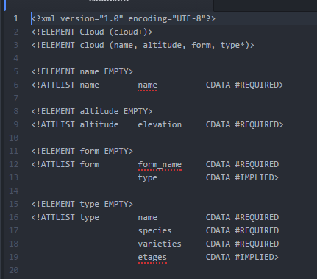

My XML sheet:

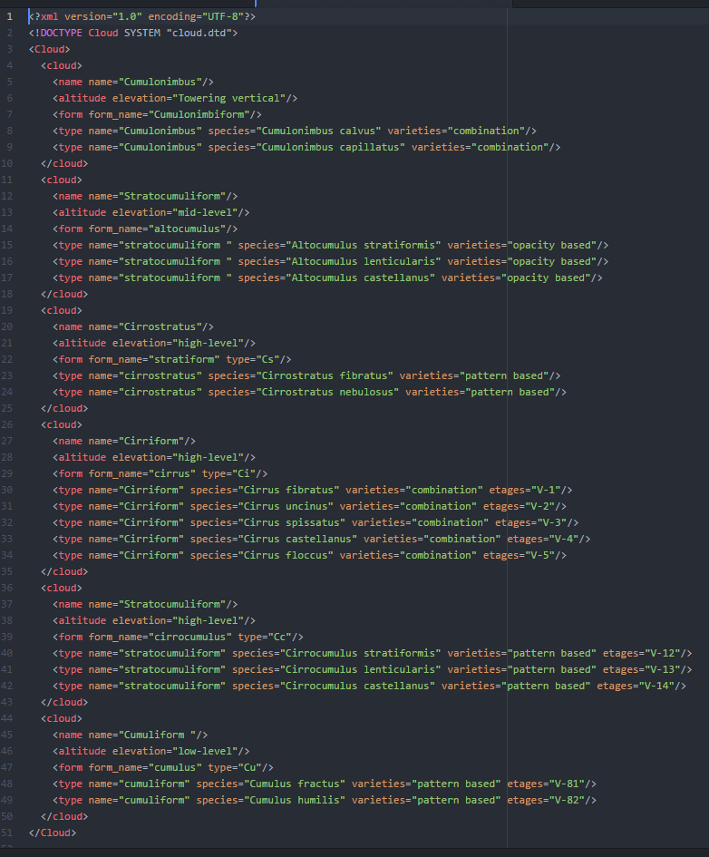

Passing the is valid:

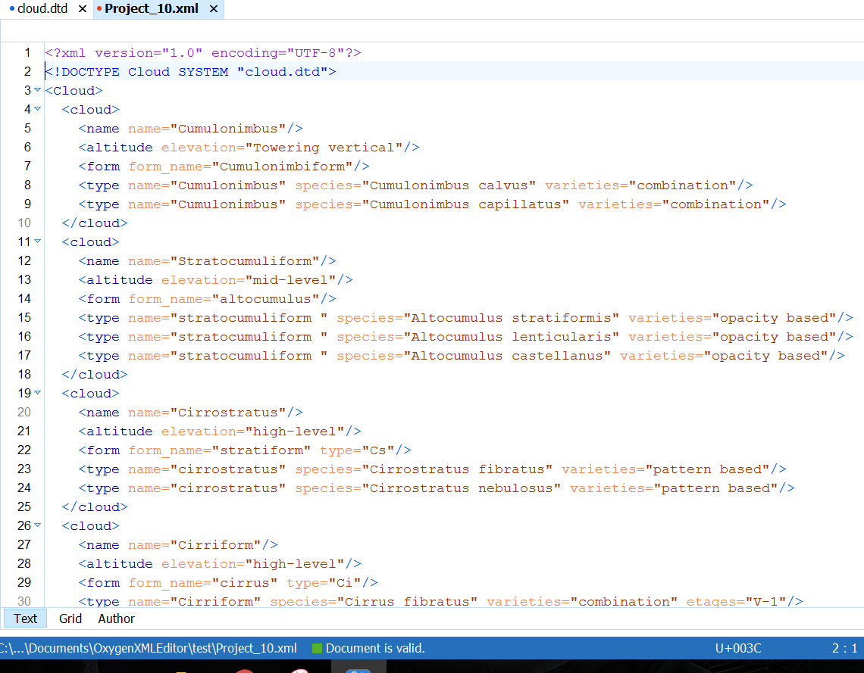

Conclusion

In conclusion, this was a rather easy lab. There wasn’t a whole lot to it. The only problems I encountered were understand what you actually wanted from this project. I had to confer with some peers just to understand what was expected. For some reason the simplicity was going over my head.